**PURBANCHAL UNIVERSITY**

**Biratnagar, Nepal**



A Project report on

**“Bike Rental System”**

In the partial fulfillment for the requirement of the 2nd Semester Project-I (subject code- BIT 156CO) in the completion of **Bachelor of Information Technology (BIT)** degree at **KIST college** **of Information Technology**, under **Purbanchal University.**

|  |  |
| --- | --- |
| **Submitted by :** | **Submitted to :** |
| **Hawana Tamang** |  |
| **Kushal Pathak** | **Purbanchal University** |
| **Romiya Dangol** |  |
| **Sama Nemkul Shrestha** |  |

**Under The Guidance of**

**Mr. Deepak Khadka**

**Lecturer, BIT**

**KIST COLLEGE OF INFORMATION AND TECHNOLOGY KAMALPOKHARI, KATHMANDU NEPAL**

**KIST COLLEGE OF INFORMATION AND TECHNOLOGY KAMALPOKHARI, KATHMANDU, NEPAL**



**CERTIFICATE**

This is to certify that the project work entitled **“BIKE RENTAL SYSTEM”** is carried out by **HAWANA TAMANG (5413), KUSHAL PATHAK (5398), ROMIYA DANGOL (5402) SAMA NEMKUL SHRESTHA (5399),** Bonafide students of **KIST COLLEGE OF INFORMATION AND TECHNOLOGY** in partial fulfillment for the award of **BACHELOR IN INFORMATION AND TECHNOLOGY** of the **PURBANCHAL UNIVERSITY, BIRATNAGAR NEPAL**, during the year **2021-2022**. It is certified that all corrections indicatedfor internal assessment have been incorporated in the report submitted in the department library. The project report has been approved, as it satisfied the academic requirements in respect of the project work prescribed for the said degree.

The details of the students are as follows: -

|  |  |  |
| --- | --- | --- |
| **NAME** | **REGISTRATION NO.** | **SYMBOL NO.** |
| Hawana Tamang | 058-3-2-04719-2020 | 324617 |
| Kushal Pathak | 058-3-2-04722-2020 | 324619 |
| Romiya Dangol | 058-3-2-04735-2020 | 324632 |
| Sama Nemkul Shrestha | 058-3-2-04736-2020 | 324633 |

Course Semester: - 2nd Semester

Subject: - Project-I

Subject Code: - BIT (156CO)



Mr. Deepak Khadka

Program Coordinator, BIT

**KIST COLLEGE OF INFORMATION AND TECHNOLOGY KAMALPOKHARI, KATHMANDU**

**Examiners Certificate**

Project report

On

**“Bike Rental System”**

**Developed by**

**Hawana Tamang**

**Kushal Pathak**

**Romiya Dangol**

**Sama Nemkul Shrestha**

Is approved and is acceptable in qualify form.

External Examiner:

Name:

Designation:

Internal Examiner:

Name:

Designation:

**ACKNOWLEDGEMENT**

It is with greatest satisfaction and euphoria that we are submitting our project report entitled **“Bike Rental System”.** We have completed it as a part of the curriculum of **PURBANCHAL UNIVERSITY.**

We also take this opportunity to express a deep sense of gratefulness to our **Lecturer Mr. Deepak Khadka** for their amiable support, valuableinformation and guidance which helped us in completing this task throughout its various stages. We are indebted to all members of **KIST College,** for the valuable support and suggestion provided by them using their specific fields’ knowledge. We are grateful for their cooperation during the period of our project.

Finally, we would also like to express our gratefulness towards **Purbanchal University** for designing such a wonderful course structure. It will help us to get more knowledge in the field of Information Technology & help us to have a bright future in the field of technology.

We hope our university will accept this attempt as a successful project.

Last but not the least, our sincere thanks to our parents, teaching and non-teaching staffs of our college and also my friends.

**HAWANA TAMANG (324617)**

**KUSHAL PATHAK (324619)**

**ROMIYA DANGOL (324632)**

**SAMA NEMKUL SHRESTHA (324633)**

**STUDENT’S DECLARATION**

We hereby declare that the project report entitled “**Bike Rental System**” is a result of our own work. If we are found guilty of copying any other report or published information and showing as our original work, we understand that we shall be liable and punishable by **Purbanchal University**.

We further certify that this Project submitted in partial fulfillment of the requirement for the award of Bachelor in Information Technology (**BIT**) of the **Purbanchal University** is our original work and has not been submitted for award of any other degree or other similar title or prize.

|  |  |  |  |
| --- | --- | --- | --- |
| **S.N.** | **Name** | **Registration No.** | **Symbol No.** |
| 1 | Hawana Tamang | 058-3-2-04719-2020 | 324617 |
| 2 | Kushal Pathak | 058-3-2-04722-2020 | 324619 |
| 3 | Romiya Dangol | 058-3-2-04735-2020 | 324632 |
| 4 | Sama Nemkul Shrestha | 058-3-2-04736-2020 | 324633 |

**TO WHOM IT MAY CONCERN**

This is to certify that **Miss. Hawana Tamang, Mr. Kushal Pathak, Miss. Romiya Dangol, and Miss. Sama Nemkul Shrestha of Bachelor in Information Technology (BIT)** has studied as per the curriculum of **BIT 2nd Semester** and completed the project entitled “**BIKE RENTAL** **SYSTEM”**.This project is the original work of **Miss. Hawana Tamang, Mr.** **Kushal Pathak, Miss, Romiya Dangol Miss. Sama Nemkul Shrestha** and was carried out under the supervision of **Mr.** **Deepak Khadka** as per the guidelines provided by **Purbanchal University** and certified as per the student’s declaration that project “**Bike Rental System**” has not been presented anywhere as a part of any other academic work.

The detail of the student is as follows:

Name of Students : Hawana Tamang

Kushal Pathak

Romiya Dangol

Sama Nemkul Shrestha

Semester : 2nd

Subject Code : BIT 156C0

Project Title : **Bike Rental System**

…………………………….

Mr. Deepak Khadka  
Program Coordinator, BIT  
KIST College of Information Technology

# ABSTRACT

The purpose of **“Bike Rental System”** is to automate the existing manual system by the help of computerized equipment’s and full-fledged computer software, fulfilling their requirements, so that their valuable data/information can be stored for a longer period with easy accessing and manipulation of the same. The required software and hardware are easily available and easy to work with.

**Bike Rental System,** as declared above, can lead to error free, secure, reliable and fastmanagement system. It can assist the user to concentrate on their other activities rather to concentrate on the record keeping. Thus, it will help organization in better utilization of resources. The organization can maintain computerized records without redundant entries. That means that one need not be distracted by information that is not relevant, while being able to reach the information.

The aim is to automate its existing manual system by the help of computerized equipment and full-fledged computer software, fulfilling their requirements, so that their valuable data/information can be stored for a longer period with easy accessing and manipulation of the same. Basically, the project describes how to manage for good performance and better services for the clients.

**According’s:** BRS refers to Bike Rental System

**TABLE OF CONTENTS**

ABSTRACT

CHAPTER 1 1

INTRODUCTION 1

1.1. INTRODUCTION 1

1.2. PROBLEM STATEMENT 2

1.3. OBJECTIVES 2

1.4. SCOPE 3

1.5. ADVANTAGES 4

CHAPTER 2 5

SYSTEM DESIGN 5

2.1. ALGORITHM 5

2.2. FLOWCHART 10

CHAPTER 3 30

REQUIREMENT ANALYSIS AND IMPLEMENTATION 30

3.1. SYSTEM REQUIREMENTS 30

3.2. SYSTEM METHODOLOGY 31

3.3. REQUIREMENT ANALYSIS 32

3.4. SYSTEM DESIGN 33

3.5. ENTITY RELATION DIAGRAM 34

3.6. FUNCTION MODULE 35

3.7. IMPLEMENTATION 37

3.8. INTEGRATION AND TESTING 37

3.9. DEPLOYMENT AND MAINTENANCE 38

CHAPTER 4 39

CONCLUSION AND FUTURE SCOPE 39

4.1. CONCLUSION 39

4.2. FUTURE SCOPE 40

REFERENCES 41

5. APPENDICES 42

5.1 SCREENSHOTS 42

5.2. SOURCE CODE 42

# CHAPTER 1

## INTRODUCTION

### 1.1. INTRODUCTION

The BRS has been developed to override the problems prevailing in the practicing manual system. This software is supported to eliminate and, in some case, reduce the hardships faced by this existing system. Moreover, this system is designed for the particular need of the company to carry out operations in a smooth and effective manner.

Bike Rental System is a desktop-based application ticketing. This application is developed by using C++ programming language. It is an easy and time-efficient way of storing the data. These data can be easily accessed by the admin.

Customers having bike license but no bike are bound to travel in buses, taxis etc. which is more time consuming despite having permit for riding bike or scooters. There are other means for travelling like pathao, tootle, indriver etc. but only one person can ride in the bike as bike rider is present. If a person wants to go in a significant place with friends or other partners, then its more time consuming while traveling in bus and taxis are also expensive. There are many bike recondition houses having bikes unused, there is no specific system so that the unused bikes will be in use and provide suitable environment to the customers to ride the vehicle.

The bike rental system facilitates the customer to enquire about the bikes available on the basis of two category petrol and electric bike having multiple option of bike under them. The aim of the case study is to design and develop file maintaining records of different bikes and details of customers. It is computerized system of renting the bikes in advance. In the given project we will be developing a website which will help users to find bike, rent and cancel the renting process.

### 1.2. PROBLEM STATEMENT

The major challenges that customers had faced while manual booking system was it was time consuming and less efficient. There was no system for renting the bike on their own. There was no bike provided to the customers of the basis of the license of the rider. Only limited companies provide bike in renting and there are more customers having rider license. The details of the customers and the bike are kept manually which may lead to loss of the data and information.

### 1.3. OBJECTIVES

The objectives of the system are-

* To manage the personal details of customer bike.
* It manages all the information about bike, customer details, payment.
* To calculate the rent.
* To update and modify the bike details if necessary.
* It contains information about the bike and the customer.
* To reduce manual work for managing the bike and the customer detail.
* It tracks all the details of the customer, payment etc.
* To make sure a user gets faster response to complete the process. [1]

### 1.4. SCOPE

This software package can be readily used by non-programming personal avoiding human handled chance of error. This project is only used by administrative users.

The aim of this proposed system is to develop a system of improved facilities. The proposed system can overcome all the limitations of the existing systems. The system provides proper security and reduces the manual work.

This project has a large scope as it has the following features which help in making it easy to use, understand and modify it:

* Simplified management of User information
* Security of data
* User registration
* Minimize manual data entry
* Minimum time needed for various processing
* Automation of the renting procedure
* Greater Efficiency
* Better service
* To satisfy the user requirement.
* Easy to understand by User and operator.
* To save the environment by using paper free work. [2]

### 1.5. ADVANTAGES

* Low cost and Affordability
* Manage the information of bike.
* To increase efficiency of managing the bike and details of customer
* It generates the report in bike, rent, and Customer etc.
* Cut the overloads of the staff’s member.
* Gives you freedom
* It tracks all the information of Renting, Passenger, seat etc.
* Shows the information and description of the Bike, Receipt, and Customer details.
* Editing, adding and updating of data is improved which results in proper resource management of Train data. [1] [3]

# CHAPTER 2

## SYSTEM DESIGN

### 2.1. ALGORITHM

Step1: Start

Step 2: Press any key to continue

Step 3: Enter your choice

Step 4: If choice is 1

Step 4.1: Enter the password

Step 4.2: Compare password with password saved in a file

Step 4.3: If password matches go to step 4.3.1

Else go to step 1

Step 4.3.1: Enter your choice

Step 4.3.2: If choice is 1

Step 4.3.2.1: Enter your choice

Step 4.3.2.1.1: If choice is 1

Step 4.3.2.1.1.1: Enter bike name

Step 4.3.2.1.1.2: Enter year

Step 4.3.2.1.1.3: Enter max power

Step 4.3.2.1.1.4: Enter max torque

Step 4.3.2.1.1.5: Enter your choice

Step 4.3.2.1.1.5.1: If choice is y go to step 4.3.2.1.1.1

Else

Go to step 4.3.2.1

Step 4.3.2.1.2: If choice is 2

Step 4.3.2.1.2.1: Enter bike name

Step 4.3.2.1.2.2: Enter year

Step 4.3.2.1.2.3: Enter range

Step 4.3.2.1.2.4: Enter your choice

Step 4.3.2.1.2.4.1: If choice is y go to

step 4.3.2.1.1.1

Else

Go to step 4.3.2.1

Step 4.3.3: If choice is 2

Step 4.3.3.1: Enter your choice

Step 4.3.3.2: If choice is 1 display petrol bikes

Else display electric bikes

Step 4.3.4: If choice is 3

Step 4.3.4.1: Enter your choice

Step 4.3.4.2: Enter the bike name

Step 4.3.5: If choice is 4

Step 4.3.5.1: Enter your choice

Step 4.3.5.2: If choice is 1

Step 4.3.5.2.1: Enter bike Id

Step 4.3.5.2.2: Check condition

If true

Step 4.3.5.2,3: Enter year, max power, max torque

Go to step 4.3.1

Else print bike not found

Step 4.3.5.3: If choice is 2 then enter the bike Id and check the condition if true then goto step 4.4.5.3.1

Step 4.3.5.3.1: Enter year, range else print Invalid choice and goto step 4.3.1

Step 4.3.6: If choice is 5

Step 4.3.6.1: Enter your choice

Step 4.3.6.2: If choice is 1

Step 4.3.6.2.1: Enter bike id

Step 4.3.6.2.2: Check Condition

If true

Step 4.3.6.2.3:print bike deleted goto step 4.3.1

Else bike not found 4.3.1

Step 4.3.6.3: If choice is 2

Step 4.3.6.3.1: Enter bike id

Step 4.3.6.3.2: Check Condition

If true

Step4.3.6.3.2.1: print bike deleted goto step 4.3.1

Else bike not found goto step 4.3.1

Step 5: If choice is 2

Step 5.1: Enter the username

Step 5.2: Enter the password

Step 5.3: Enter the username and password

Step 5.4: Press any key to continue

Step 5.5: Choose your category

Step 5.5.1: If choice is 1

Step 5.5.1.1: Enter your choice

If choice is 1 go to step 5.5.1.1.1

Step 5.5.1.1.1: Enter how many days you want to rent the bike

Step 5.5.1.1.2: Enter your name

Step 5.5.1.1.3: Enter your gender

Step 5.5.1.1.4: Enter your age

Step 5.5.1.1.5: Enter the contact number

Step 5.5.1.1.6: Enter citizenship number

Step 5.5.1.1.7: Enter your choice for bike

Step 5.5.1.1.8: Enter the advance amount for rental

Step 5.5.1.1.9: Enter your choice

If choice is y go to step 5.5.1.1.1

Else go to step 7

If choice is 2 go to step 5.5.1.2.1

Step 5.5.1.2.1: Enter how many hours you want to rent a bike

Step 5.5.1.2.2: Enter your name

Step 5.5.1.2.3: Enter your gender

Step 5.5.1.2.4: Enter your age

Step 5.5.1.2.5: Enter the contact number

Step 5.5.1.2.6: Enter citizenship number

Step 5.5.1.2.7: Enter your choice for bike

Step 5.5.1.2.8: Enter the advance amount for rental

Step 5.5.1.1.9: Enter your choice

If choice is y go to step 5.5.1.2.1

Else go to step 7

Step 6: If choice is 3

Step 6.1: Enter the username

Step 6.2: Enter the password

Step 6.3: Press any key to continue

Step 6.4: Choose your category

Step 6.4.1: If choice is 1

Step 6.4.1.1: Enter your choice

If choice is 1 go to step 6.4.1.1.1

Step 6.4.1.1.1: Enter how many days you want to rent the bike

Step 6.4.1.1.2: Enter your name

Step 6.4.1.1.3: Enter your gender

Step 6.4.1.1.4: Enter your age

Step 6.4.1.1.5: Enter the contact number

Step 6.4.1.1.6: Enter citizenship number

Step 6.4.1.1.7: Enter your choice for bike

Step 6.4.1.1.8: Enter the advance amount for rental

Step 6.4.1.1.9: Enter your choice

If choice is y go to step 6.4.1.1.1

Else go to step 7

If choice is 2 go to step 6.4.1.2.1

Step 6.4.1.2.1: Enter how many hours you want to rent a bike

Step 6.4.1.2.2: Enter your name

Step 6.4.1.2.3: Enter your gender

Step 6.4.1.2.4: Enter your age

Step 6.4.1.2.5: Enter the contact number

Step 6.4.1.2.6: Enter citizenship number

Step 6.4.1.2.7: Enter your choice for bike

Step 6.4.1.2.8: Enter the advance amount for rental

Step 6.4.1.1.9: Enter your choice

If choice is y go to step 6.4.1.2.1

Else go to step 7

Step 7: End

### 

### 2.2. FLOWCHART

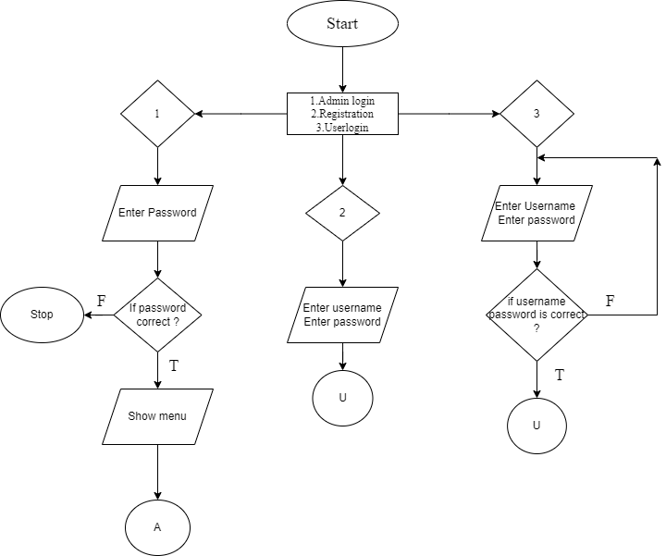

Figure 1:Flowchart1

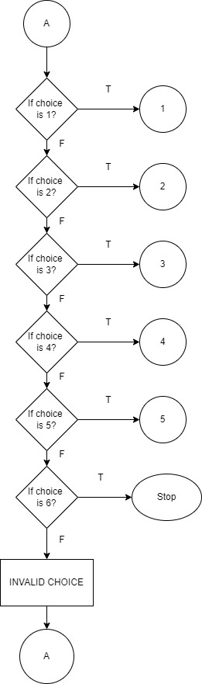

Figure 2:Flowchart2

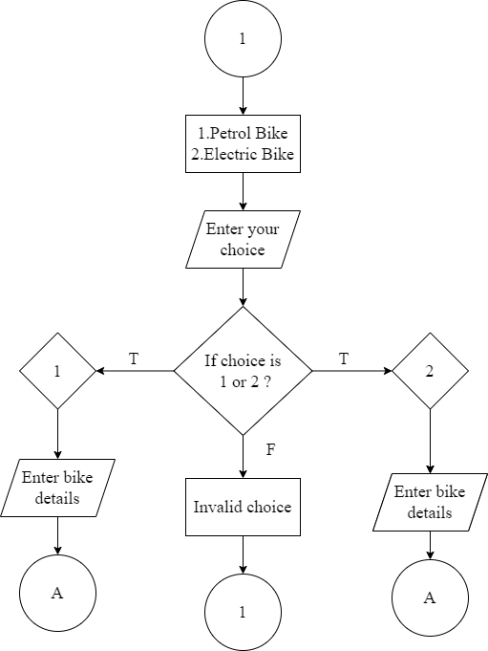

Figure 3:Flowchart 3

# 

Figure 4:Flowchart4

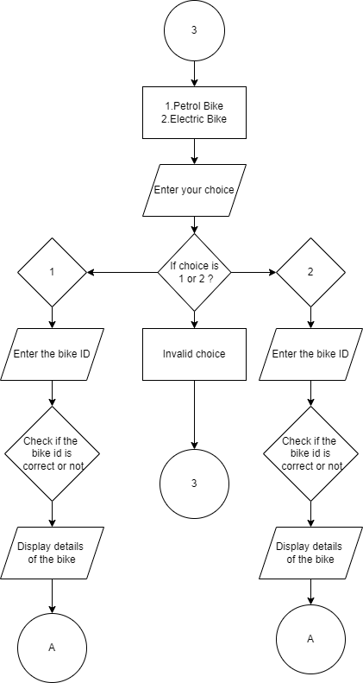

Figure 5 : Flowchart5

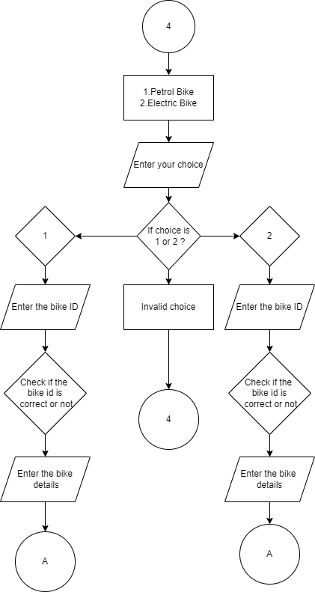

Figure 6:Flowchart6

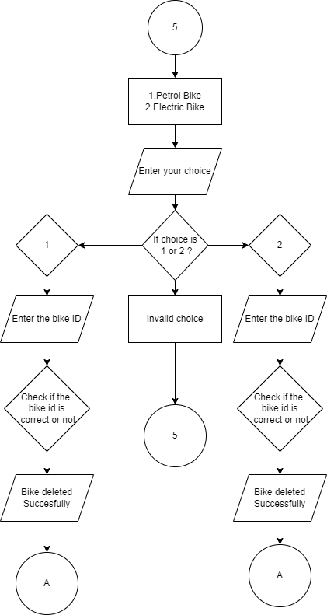

Figure 7:Flowchart7

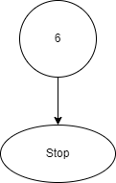

Figure 8 : Flowchart8

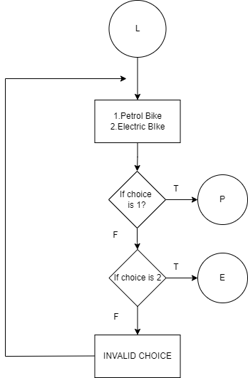

Figure 9 :Flowchart9 Figure 10 : Flowchart10

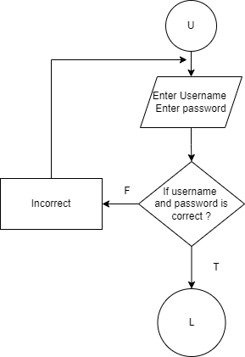

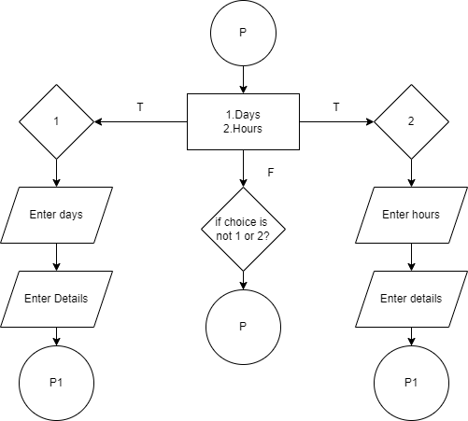

Figure 11 : Flowchart11

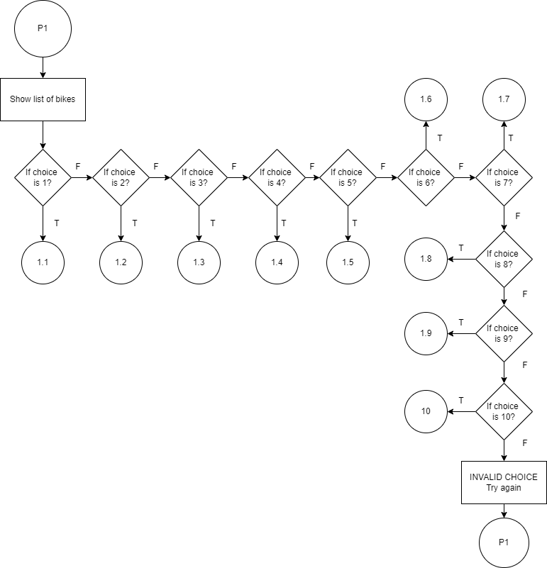

Figure 12 : Flowchart12

# 

Figure 13: Flowchart 13 Figure 14 :Flowchart14 Figure 15:Flowchart15

# 

|  |  |  |
| --- | --- | --- |
| **Figure 16: Flowchart 16** | **Figure 17: Flowchart 17** | **Figure 18: Flowchart 18** |

|  |  |  |
| --- | --- | --- |
| **Figure 19: Flowchart 19** | **Figure 20: Flowchart 20** | **Figure 21: Flowchart 21** |

**Figure 22: Flowchart 22**

# 

# 

**Figure 24: Flowchart 24**

**Figure 23: Flowchart 23**

**Figure 25: Flowchart 25**

# 

# 

# 

**Figure 26: Flowchart 26**

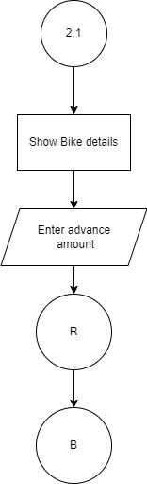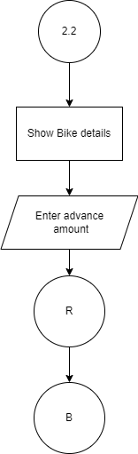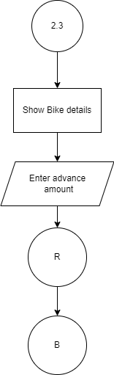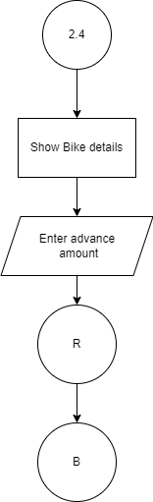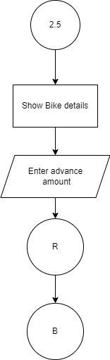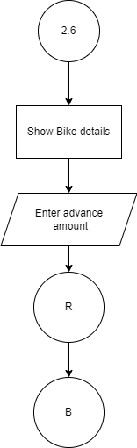

**Figure 27: Flowchart 27 Figure 28: Flowchart 28 Figure 29: Flowchart 29**

**Figure 30: Flowchart 30 Figure 31: Flowchart 31 Figure 32: Flowchart 32**

# CHAPTER 3

## REQUIREMENT ANALYSIS AND IMPLEMENTATION

### 3.1. SYSTEM REQUIREMENTS

Following hardware and software requirement should be met for flawless running of this system:

**MINIMUM REQUIREMENTS:**

**PROCESSOR**: Intel core i3 or i5

**SPEED**: 1.5Hz

**RAM**: 4 GB

**HARDDISK**: 20MB (At least 80MB of free space)

**MONITOR**: LCD MONITOR

**OPERATING SYSTEM**: WINDOWS XP, 2000 Professional

**COMPILER**: DEV C++, Visual Studio

### 3.2. SYSTEM METHODOLOGY

**WATERFALL MODEL**

The waterfall model is a classical model used in system development life cycle to create a system with linear and sequential approach. It is termed as waterfall because the model develops systematically from one phase to another in a downward fashion. In waterfall model the requirements are very well documented, clear and fix. The project done under waterfall model is short and the product definition is stable. [4]

**The sequential phases described in the Waterfall model are:**

Deployment and Maintenance

Integration and Testing

Implementation

System Design

Requirement Analysis

Figure33: Waterfall model

### 3.3. REQUIREMENT ANALYSIS

**FUNCTIONAL REQUIREMENT**

In software and system engineering, a functional requirement defines a function of a system or its component, where a function is described as a specification of behavior between input and outputs. [5]

### 

Bike Rental System

### 

User

Admin

**Figure 34: Use Case Diagram**

### 3.4. SYSTEM DESIGN

System design is the process of designing the architecture, components, and interfaces for a system so that it meets the end-user requirements. A good system design is to organize the program modules in such a way that are easy to develop and change. There are many strategies or techniques for performing system design. [4]

* **Importance**:
* If any pre-existing code need to be understood, organized, and pieced together.
* It is common for the project team to have to write some code and produce original programs that support the application logic of the system.

There are many strategies or techniques for performing system design.

* **Bottom – up approach:** Bottom – up is an approach used in integration testing, which is a level of software testing where individual units are combined and tested as groups. Integration Testing is performed by software testers once unit testing is completed and before the inception of system testing
* **Advantages of Bottom - up approach:**
* The bottom – up style allows managers to communicate goals and value through milestone planning, and team members are encouraged to develop personal to – do lists with the steps necessary to reach the milestones on their own.
* A clear advantage of this approach is that it empowers team members to think more creatively.

### 3.5. ENTITY RELATION DIAGRAM

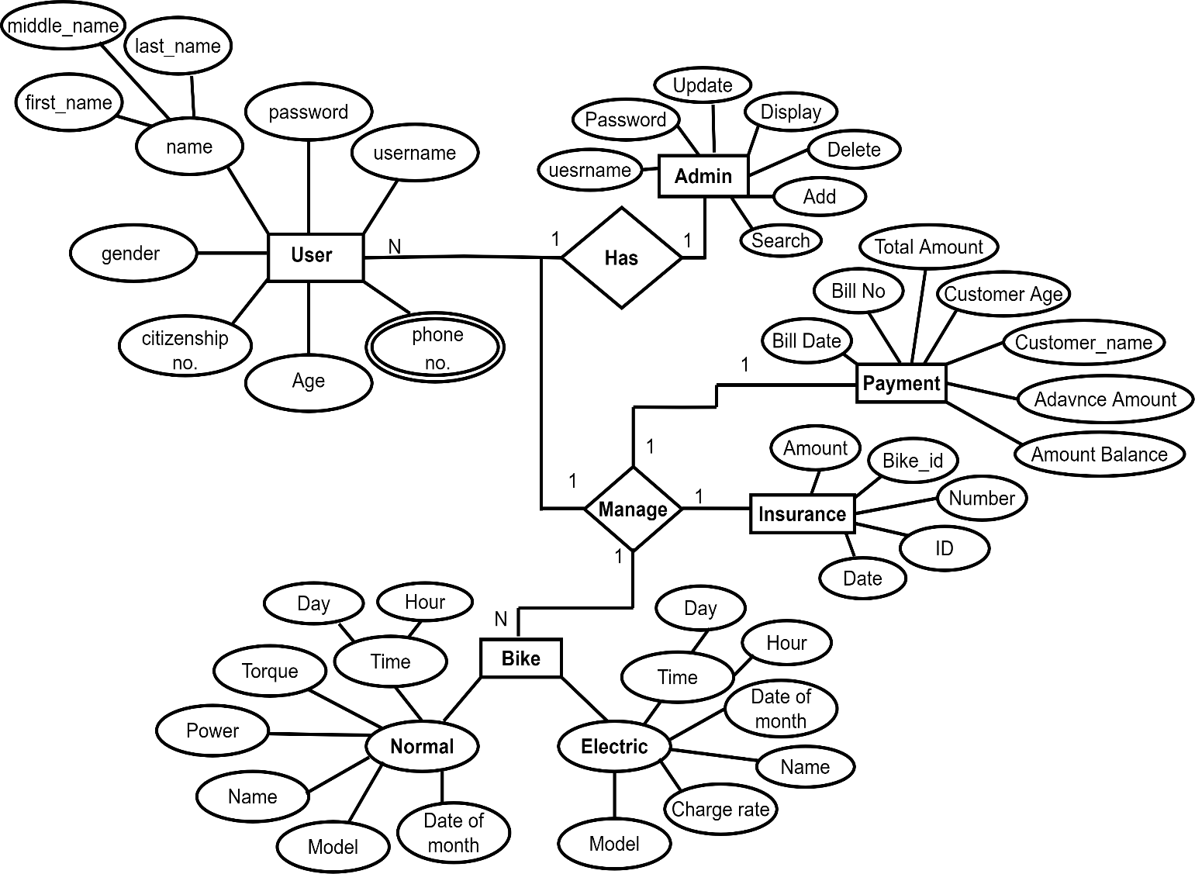

**Figure 35: ER Diagram**

### 3.6. FUNCTION MODULE

|  |  |  |
| --- | --- | --- |
| **No.** | **Function module** | **Function Description** |
| **1.** | **userlogin()** | This function is for security purpose so that person the registered user cannot manipulate the system or program. |
| **2.** | **adminlogin()** | This function is for security purpose only for the admin. |
| **3.** | **userregister()** | This function is for the new user registration in the system. |
| **4.** | **time1()** | This function is for the display of current time, day, date. |
| **5.** | **display1()** | This function is to display the list of petrol or normal bikes. |
| **6.** | **display2()** | This function is to display the list of electric bikes. |
| **7.** | **get_bike1()** | This function is to choose the specific normal or petrol bike. |
| **8.** | **get_bike2()** | This function is to choose the specific electric bike. |
| **9.** | **warning1()** | This function is to display the warning for the petrol or normal bike. |
| **10.** | **warning2()** | This function is to display the warning for the electric bike. |
| **11.** | **calcuRent1()** | This function is to calculate the rent for the petrol or normal bike. |
| **12.** | **calcuRent2()** | This function is to calculate the rent for the electric bike. |
| **13.** | **add_bikes()** | This function is for the admin to add the bike in the system. |
| **14.** | **show_bike()** | This function is for the admin to show the list of bikes present in the system. |

|  |  |  |
| --- | --- | --- |
| **15.** | **check_bike()** | This function is to check the specific bike in terms of their bike id . |
| **16.** | **update_bike()** | This function is to update the existing bike. |
| **17.** | **del_bike()** | This function is to delete the existing bike. |

### 3.7. IMPLEMENTATION

This phase is initiated after the system has been testes and accepted by the user. System performance is compared to performance objectives established during the planning phase. System implementation is a process of ensuring that the information system is operational. Implementation allows the users to take over its operation for use and evaluation.

Implementation includes user notification, user training, installation of hardware, installation of software onto production computers, and integration of system into daily work processes. This phase continues until the system is operating in production in accordance with the defined user requirements. [4]

* We used C++ programming to implement our project.
* File Handling was used for the data and records.
* Functions for sub modules.
* The system is first developed in small programs called units, which are integrated in the next phase. The testing of each developed unit individually is referred as unit testing.

### 3.8. INTEGRATION AND TESTING

The systems integration test function is to ensure that the developed systems meet all the technical requirements with the components and subsystems integrated. All the modules/functions are tested. Individual functions are provided and output is generated. The code is tested through the unit testing. [4]

* **Unit Testing:** A testing technique using which individual modules are tested to determine if there are any issues to be fixed. It is concerned with functional correctness of the standalone modules. The main aim is to isolate each unit of the system to identify, analyze and fix the defects.
* **Advantages of unit testing**
  + Reduces defects in the newly developed features or reduces bugs when changing the existing functionality.
  + Reduces Cost of testing defects are captured in very early phase
  + Improves design and allows better refactoring of code.
  + Unit tests, when integrated with build gives the quality of the build as well.

### 3.9. DEPLOYMENT AND MAINTENANCE

* The deployment phase is the final phase of the software development life cycle (SDLC) and puts the product into production.
* After the project team tests the product and the product passes each testing phase, the product is ready to go live. This means the product is ready to be used in a real environment by all end users of the product.
* Once the functional and non-functional testing is done, the product us deployed in the customer environment or released into the market.
* After the product is deployed to the user’s market from there the maintenance phase starts
* Once the product or the system is in use there will be many patches to be fixed.
* The user might ask for new features and enhancements. It is the responsibility of the maintenance team to attend to these requests and to fix the bugs that are found.
* The maintenance effort revisits all the other stages of the software life cycle.
* Each modification requires planning, specification, design, coding, testing, installation. [5]

# CHAPTER 4

## CONCLUSION AND FUTURE SCOPE

### 4.1. CONCLUSION

Our project is only a humble venture to satisfy the needs to manage the project work. Several user-friendly coding has also been adopted. This package shall prove to be a powerful package in satisfying all the requirements of the school. The objective of software planning is to provide a frame work that enables the manager to make reasonable estimates made within a limited time frame at the beginning of the software project and should be updated regularly as the project progresses.

**At the end it is concluded that we have made effort on following points**

* A description of the background and context of the project and its relation to work already done in the area.
* The description of Purpose, Scope, and applicability.
* We define the problem on which we are working in the project.
* We describe the requirement Specifications of the system and the actions that can be done on these things.
* We included features and operations in detail, including screen layouts.
* Finally, the system is implemented and tested according to test cases.

### 4.2. FUTURE SCOPE

In a nutshell, it can be summarized that the future scope of the project circles around maintaining information regarding:

* We can give more advance software for **“Bike Rental System”** including more facilities.
* We can add the more bikes and make the system more relevant and efficient.
* Online booking can be integrated.
* Rental details, customer data. can be updated and reports can be generated.
* Integrate multiple load balancers to distribute the loads of the system.
* User interface can be made more effective.
* In future, this system has the scope of being used as web version where both the admin and user can easily access the system with their individual username and password.

The above-mentioned points are the enhancements which can be done to increase the applicability and usage of this project. Here we can maintain the records of Contact and credential. Enhancements can be done to maintain all the Contact, Credential, Telephone, Profile, Emails. [3]

# REFERENCES

|  |  |
| --- | --- |
| [1] | FreeProjectz, "FreeProjetz," [Online]. Available: https://www.freeprojectz.com/premium-synopsis  /synopsis-car-rental-system |
| [2] | Balaknnav, "Abservetech," [Online]. //www.abservetech.com/blog/what-is-the-scope-of-car-rental-  script-for-your-business/. |
| [3] | lovelycoding, "Lovelycoding," https://www.lovelycoding.org/bike-rental-system/. |
| [4] | J. A.Hoffer, Modern System Analysis and Design, Benjamin-Cummings Pub Co(May 1 1996). |
| [5] | R. S.PRESSMAN, SOFTWARE ENGINEERING , A PRACTITIONER'S APPROACH,  vol. Fourth Edition, E. M. munson, Ed., McGraw-Hill Companies,inc, 1997. |

# 5. APPENDICES

## 5.1 SCREENSHOTS

## 5.2. SOURCE CODE